REST API

Flask

--> Making websites

--> Rest APIs

--> micro web services

--> light weight module

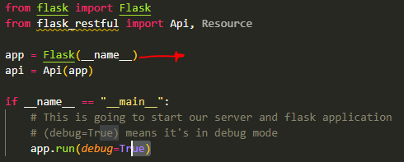

**In this case __name__ represents the name of the application package and it’s used by Flask to identify resources like templates, static assets and the instance folder.**

[**https://codefather.tech/blog/python-__name__-flask/**](https://codefather.tech/blog/python-__name__-flask/)

**Every time when we return some type of information from our API we need to make sure that information is json serializable**

**Example: This is a json object**

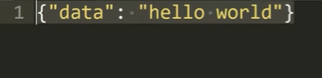

**When we run in debug mode 🡪 And when we save it … it automatically gets updated**

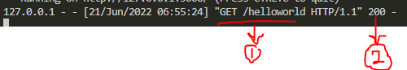

**The above means that there is a get request to /helloworld and status = 200**

REST APIs

RE --> Representational

S --> State

T --> Transfer

API --> Application Programming Interface

An API is an interface through which one program or web site talks to another.

They are used to share data and services, and they come in many different

formats and types.

Representational State Transfer (REST) is an architectural style that defines a set of constraints to be used for

creating web services. REST API is a way of accessing web services in a simple and flexible way without having any

processing.